|  |  |
| --- | --- |
| cid:image004.png@01CF7F10.A4275880 | LOGO4 |
| Best Buy Canada Mobile | |
| |  | | --- | | **Sale Feature Document** |   **Document Version: 1.1**  **Revision Date: March 23, 2015** | |
| **Prepared By: Amy Byers** | |
|  | |

**Table of Contents**

*1.* *Feature Overview* 3

1.1 Feature Description 3

1.2 Assumptions 3

1.3 Parameters and System Settings 3

1.4 Interfaces 4

*2.* *USE CASE: Sale* 5

2.1 Feature Flow 5

2.2 Precondition 6

2.3 Main Flow 7

2.4 Alternate Flows 8

2.5 Post Condition 9

2.6 Special Requirements 9

*3.* *USE CASE: Price Required* 10

3.1 Feature Flow 10

3.2 Precondition 10

3.3 Main Flow 10

3.4 Alternate Flows 10

3.5 Post Condition 10

3.6 Special Requirements 10

*4.* *USE CASE: Open Box Item* 11

4.1 Feature Flow 11

4.2 Precondition 11

4.3 Main Flow 11

4.4 Alternate Flows 11

4.5 Post Condition 12

4.6 Special Requirements 12

*5.* *Supplemental Specifications* 12

5.1 Deal Service Feature 12

5.2 Item Lookup Service Feature 12

5.3 Electronic Journal 12

5.4 Manager Override 12

5.5 POSLog 12

5.6 Printed Receipts 12

5.7 Related Items Feature 13

5.8 Suspend Feature 13

5.9 Tax Service Feature 13

*6.* *Screen Layouts* 14

6.1 Item Entry 14

6.2 Enter Price 17

6.3 Enter Open Box Price 18

*7.* *Business Sign Off* 19

*8.* *Revision History* 19

*9.* *Appendix A: Glossary* 19

# *Feature Overview*

## Feature Description

The Sale Feature Document describes the functionality of creating transactions by adding or editing items. Additional functionality is available within the Sale feature to modify items or the transaction such as capturing a serial number, modifying the prices of items, and verifying the age of the customer. The Sale use case ends when the operator selects to pay for (tender) the transaction.

## Assumptions

1. All quantity required items will have quantity of 1.
2. Items that are not in scope to be sold in the release are set with the item not eligible to be sold on mobile device attribute.
3. Suggested Sell is a passive process and thus is purely optional. Warranty items are the only items available as Suggested Sell items.
4. All text displayed by the system is configurable by brand to support multi-language.  Text is defined from an external source or defined within the system.

## Parameters and System Settings

| **Parameter Mnemonic** | **Description** | **Valid Values** |
| --- | --- | --- |
| Price Override Allowed Item Attribute | Determines if price override can be applied to the item. | * On * Off |
| Manually Discount Item Attribute | Determines if the item is eligible for manual item discount. | * On * Off |
| System Promotion Allowed Item Attribute | Determines if the item is eligible for system promotions. | * On * Off |
| Include in Global package qualification, but not in prorating Item Attribute | Determines items that are eligible to be part of package pricing, but is not included in any proration that occurs. | * On * Off |
| Kit Eligible Item Attribute | Determines if the item is eligible to be part of a kit. | * On * Off |
| Customer Capture Item Attribute | Determines if a customer is required to be captured. | * On * Off |
| Item Not Available to Be Sold on Mobile Item Attribute | Determines if the item is not eligible to be sold on mobile device. | * On * Off |
| Age Verification Item Attribute | Determines if the item is an age verification item that requires confirmation prior to selling the item | * On * Off |
| Serialized Item Attribute | Determines if the item requires serial number to be captured prior to selling the item. | * On * Off |
| Price Required Item Attribute | Determines if the item requires a price to be entered before the item can be sold. | * On * Off |
| Out of Transaction Inactivity Timeout | Determines by device the specified amount of time in seconds that the system needs to exceed before the system logs the operator out of mobile POS. Time starts once the operator successfully logs in and ends when a transaction is initiated. Once a transaction is initiated, the parameter is no longer used until transaction is completed. | * 5 to 300 |
| Loyalty Usage Item Attribute | Determines if the entered item is a loyalty usage item. | * On * Off |
| Loyalty Enrollment Item Attribute | Determines if the entered item is a loyalty enrollment item. | * On * Off |
| Item Modify Menu Options | Determines what functionality is available in the item modify menu. | * Gift Receipt * Price Override * Manual Item Discount * Salesperson Capture * Tax Override * Tax Exempt |
| Signature Required | Determines if a function or an acceptance of Terms and Conditions requires a signature. The parameter also defines if the signature for a feature can be consolidated. | Current Scope:   * Warranty Item – PSP * Warranty Item – PRP * Item Tax Exempt * Tran Tax Exempt * Warranty Item – Monthly * Subscription Item * General Item Attribute for Signature Capture with Terms * Loyalty Enrollment * Finance Tender * Employee Sale |
| Activation Item Attribute | An item attribute that determines if the item requires activation to complete the sale of the item. | * On * Off |
| Suggested Sell | Enables or disables Suggested Sell functionality | * On * Off |
| Item Sold Only Through Related Item Process Item Attribute | An item attribute that controls if an item can be sold only through the related item process (through optional/mandatory selection list or mandatory) and cannot be sold through entering the item in Sale: Item Entry. | * On * Off |
| Subscription Item Attribute | An item attribute that determines if the item is a subscription item. | * On * Off |
| Generic Signature Required Item Attribute | An item attribute that determines if the item requires a generic signature capture. | * On * Off |
| Sale Item Requires Manager Override Item Attribute | An item attribute that determines if the item requires manager override when the items is sold. | * On * Off |
| Require Service Scheduling | Determines if the system checks the schedulable item attribute when an item is sold through Item Entry. If an item has the Schedulable Item Attribute enabled and the item is sold through Item Entry, the system checks if manager approval is required in order to continue. | * On * Off |
| Schedulable Service Item Attribute | Item attribute that defines a schedulable item. This item attribute is used if the Require Service Scheduling parameter is enabled. | * On * Off |
| Unscheduled Schedulable Service Item Manager Override | Determines if selling a schedulable service item through item entry instead of through the import process requires manager override. | * On * Off |
| Raincheck Eligible Item Attribute | The item attribute that determines if the item is eligible for raincheck (ATTR_ID = 49). | * On * Off |

## Interfaces

| **Interface** | **Description** |
| --- | --- |
| Stella Nova Item Lookup Service | Service that returns item information |
| Stella Nova Deal Service | Service that returns deal information |
| Stella Nova Tax Service | Service that returns tax information |

# *USE CASE: Sale*

## Feature Flow

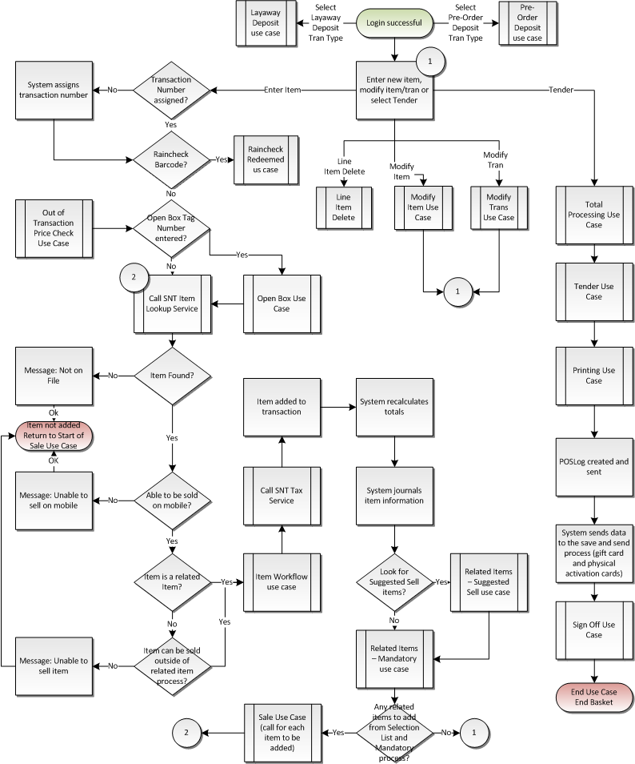

Figure 1: Sale Feature Flow



Figure 2: Sale Feature Flow – Item Workflow Processing

## Precondition

* The operator has successfully logged in to the application.

## Main Flow

1. The system prompts the operator to enter an item or select an option.
2. If the operator selects to perform a layaway deposit transaction, the system switches the transaction type to Layaway Deposit and executes the Layaway Deposit use case; the Sale use case is ended.
3. If the operator selects to perform a pre-order deposit transaction, the system switches the transaction type to Pre-Order Deposit and executes the Pre-Order Deposit use case; the Sale use case is ended.
4. If at any time the operator selects to view the transaction information, the Information alternate flow is executed.
5. If at any time the operator selects to modify the transaction, the Modify Transaction use case is executed.
6. If at any time the operator scans a Raincheck Issue barcode, the Raincheck Redeemed use case is executed.
7. The operator enters an item number and accepts the entry or selects a Suggested Sell item.
8. If a transaction number has not been assigned to the transaction, the system assigns and logs a transaction number to the basket.
9. If the entered item is an open box tag number, the Open Box Item use case is executed.
10. The system calls SNT Item Lookup Service to retrieve the item data.
11. The system receives a response.
12. If the response is that the request timed out based on Item Lookup Timeout Parameter, the system displays a message, the operator acknowledges the message and the system returns to the step in the Main Flow where the system prompts the operator to enter an item.
13. If the response is that the item was not found, the Item Not on File use case is executed.
14. The system receives item information.
15. If the item is marked as not authorized for sale on a mobile device, the system displays a message; the operator acknowledges the message, the system discards the item and the system restarts the Main Flow.
16. If the item is a related item, the main flow continues where the system checks if the item is a gift card item.
17. If the item is marked as not authorized to be sold outside of the related item process, the system displays a message; the operator acknowledges the message, the system discards the item and the system restarts the Main Flow.
18. If the item is a Schedulable Service Item, the Schedulable Service alternate flow is executed.
19. If the item requires manager override when the item is sold, the Manager Override use case is executed.
20. If the item is a Gift Card item, the Gift Card use case is executed.
21. If the item is a Warranty item, the Warranty use case is executed.
22. If the item is a Loyalty Enrollment item, the Loyalty Enrollment use case is executed.
23. If the item is a Loyalty Usage item, the Loyalty Usage use case is executed.
24. If the item requires a minimum age for purchase, the Age Verification use case is executed.
25. If the item is a price required item, the Price Required use case is executed.
26. If the item is a quantity required item, the Quantity Capture use case is executed.
27. If the item is a customer required item, the Customer use case is executed.
28. If the item requires selection list relationships, the Related Item – Selection List use case is executed.
29. If the item requires the capture of a serial number, the Serialized Item use case is executed.
30. If the item requires custom prompts, the Custom Prompts use case is executed.
31. If the item requires capturing of credit card information, the Capture Credit Card use case is executed.
32. If the item is a subscription item and it requires a signature, the Signature with Terms use case is executed.
33. If the item requires a signature, the Signature with Terms use case is executed.
34. If the item is an activation item, the Activation use case is executed.
35. The system calls the SNT Tax Service.
36. The system adds the item to the transaction
37. The system journals the item information (description, quantity, price, discount information, final price, and tax status).
38. The system updates the transaction totals.
39. The system evaluates the Suggested Sell parameter.
40. If the Suggested Sell parameter is enabled, the Related Item – Suggested Sell use case is executed.
41. The Related Item – Mandatory use case is executed.
42. The system determines if any items need to be added due to the Related Item (Mandatory and Selection List) use case processing.
43. If related items exists, the system returns to the Main Flow where the lookup service is executed for each of the related items to add.
44. If at any time the operator selects to modify an item, the Modify Item use case is executed.
45. If the operator selects to remove an item, the Line Item Delete use case is executed.
46. If the operator enters an additional item, the system returns to the step in the Main Flow where the system retrieves the item data.
47. The operator selects Tender.
48. The system executes the Total Processing use case.
49. The system executes the Tender use case.
50. The system writes the transaction to the database.
51. The system executes the Printing use case.
52. The system sends data to the Save and Send process to complete the two-step activation process.
53. The system executes the Sign Off use case.
54. The use case ends and the system returns to the calling use case.

## Alternate Flows

### Information

1. The system displays information specific to the transaction.
2. The operator acknowledges the information, the alternate flow ends and the system restarts the Main Flow.

### Schedulable Service Items

1. The system checks if the system requires service items to be scheduled.
2. If the system does not require service items to be scheduled, the system returns to the Main Flow where the system checks if the item requires manager override for sale.
3. The system checks if there are scheduled items that were imported into the transaction via the service order scheduling process.
4. If imported scheduled service items exist in the transaction, the system displays a message; the operator acknowledges the message, the system discards the item and the system restarts the Main Flow.
5. The system checks if manager override is required in order to continue.
6. If manager override is not required, the system returns to the Main Flow where the system checks if the item requires manager override for sale.
7. The system executes the Manager Override use case.
8. The system receives a manager override decision.
9. If the Manager Override use case returns with an approval or queued manager response, the system returns to the Main Flow where the system checks if the item requires manager override for sale. **Note**: The approval is queued and is processed when the operator selects to total the transaction.
10. If the Manager Override use case returns with a denied decision, the system restarts the Main Flow and the item is not added to the transaction.

## Post Condition

* A transaction is initiated.
* A transaction is completed.

## Special Requirements

1. Transaction information consists of Operator ID, Register Number, Transaction Number and Transaction Salesperson ID.
2. A transaction number is pulled from a pool of transaction numbers for the register number. Transaction numbers range from 1-9,999 for each register number and are incremented by one after each request for a transaction number. (**Note**: A register number is not the unique device ID, but is the 1-2 digit ID assigned to the device to be used in the creation of the Transaction Key. There can be multiple devices associated with one register number.)
3. For the transaction number, the system rolls back to 1 after reaching 9,999.
4. Item can be entered by scanning barcode, manually keying in item or selecting from Suggested Sell list.
5. The system accepts UPC codes in place of Item Number. An UPC value is associated with one item, and an item can have multiple UPC values.
6. The system accepts alpha-numeric values.
7. If an item is entered with a length of 9, the system assumes this is an Open Box Item.
8. When communicating with the Stella Nova Item Lookup Service, the system treats an offline/timeout response the same as no information found response.
9. For items not authorized to be sold or items with a street date in the future, the system treats these items as item not found.
10. The related items suggest sell list consists of warranty items that are associated to the product item. The checks that the current price of the item falls within the warranty item’s price band. For example if Item A is associated Warranty X, Y and Z and the warranty price band for X and Y is that the product item price needs to be between $300-$700 and warranty price band for Z is that the product item price needs to be between $500-$900, then if the product A is sold with the price of $400 then only warranty items X and Y will be displayed.
11. Suggested Sell for an item is not displayed until all steps required to add an item to a transaction are complete.
12. Selected Suggested Sell items are systematically added to the current transaction when selected and additional requirements are met where applicable (e.g. customer capture).
13. Promotions are applied when the Total option is selected.
14. Transaction level manual tax overrides apply to all future items added to the transaction.
15. If the operator is logged into the system, but is not in the middle of a transaction, the system automatically logs out the operator based on the Out of Transaction Inactivity Timeout parameter.
16. If during the add item process for any of child related items the process fails or the operator stops the adding of the item, the previous items added within the relationship are deleted.
17. The delete option is not available for an item imported from the service order scheduling system
18. If a manager approval is denied, the system restarts the Main Flow and the item is not added to the transaction.
19. Items added during the import process follow a modified sale process that is defined in the Service Order feature document:

* Activation items are not allowed in the list of items to be imported, the transaction is automatically voided if they exist.
* If the item is not found, the item is not allowed to be sold on the device or the item is not allowed to be sold outside of the related item process, the transaction is automatically voided.
* If an item requires serial number, the system does not prompt for serial number on the item.
* The quantity returned in the response is applied to the line quantity for the item being added. The quantity is greater than or equal to one. (**Note**: Once the system supports Quantity Required Items and Quantity Override Item Modification features, the capture quantity process is going to be changed to account for these scheduled items.)

1. If the transaction is turned into an employee transaction after items have been added, the system determines if employee pricing should be applied to the existing items in the transaction.
2. Employee indicator is sent to the Pricing Service.
3. If a raincheck barcode is scanned and the item is sold in the transaction, the system updates the item within the transaction with the price from the raincheck barcode.
4. If raincheck barcode is scanned and the item is not sold in the transaction, the system retains the raincheck information to apply to an item at a later point in the transaction; the use case ends and the system restarts the Sale use case.

### Special Offline Requirements

TBD

### Data Input/Output

|  |  |  |
| --- | --- | --- |
| **Data Element** | **Description** | **Destination** |
| Item Number | SKU number associated with a sales item. If the item is sold via UPC or Open Box Item processing, this is the SKU number associated with these values. | * E-Journal * POSLog |
| Item Description | Description of item being sold. | * E-Journal * POSLog |
| Quantity | Number of item sold for a given line number. | * E-Journal * POSLog |
| Item Price | Original price of a sales item. | * E-Journal * POSLog |
| Tax Status | The Taxability status of the item. If a jurisdiction is | * E-Journal * POSLog |
| Tax Amount | The tax amount applied to each tax jurisdiction on the item. | * E-Journal * POSLog |

# *USE CASE: Price Required*

## Feature Flow



## Precondition

* The operator has entered an item flagged as a Price Required item.

## Main Flow

1. The system prompts the operator to enter a price.
2. The operator enters a price and accepts the entry.
3. The use case ends and the system returns to the calling use case.

## Alternate Flows

None

## Post Condition

* A price is linked to an item.

## Special Requirements

1. An item level attribute determines if price entry is required.

### Special Offline Requirements

TBD

### Data Input/Output

|  |  |  |
| --- | --- | --- |
| **Data Element** | **Description** | **Destination** |
| None |  |  |

# *USE CASE: Open Box Item*

## Feature Flow



## Precondition

* The operator has entered an Open Box Tag

## Main Flow

1. The system checks if the open box tag number exists in the database.
2. If the open box tag does not exist, the system displays a message stating the tag number is invalid, the operator acknowledges the message and the use case ends and returns to the Sale use case where the system prompts the operator to enter an item or select an option.
3. The system determines if the open box tag has a price.
4. If the open box tag has a price greater than zero, the use case ends and the system returns to the Sale use case where the system calls the SNT Item Lookup Service.
5. If the open box tag does not have a price (value of NULL or 0.00), the system prompts the operator to enter a price.
6. The operator enters a price and accepts the entry.
7. The use case ends and the system returns to the Sale use case where the system calls the SNT Item Lookup Service.

## Alternate Flows

None

## Post Condition

* Open box tag details have been collected.

## Special Requirements

1. The system will compare the current selling price for the item to the price retrieved from the open box tag use case and use the lowest price when applying price to item.
2. An open box item is not eligible for a raincheck to be issued.

### Special Offline Requirements

TBD

### Data Input/Output

|  |  |  |
| --- | --- | --- |
| **Data Element** | **Description** | **Destination** |
| Item | The Item associated with the open box tag number | * SNT Item Lookup Service |
| Open Box Item Price | The price for the open box tag number. | * SNT Item Lookup Service |
| Open Box Tag Number | The 9-character value entered in item entry. Also called License Plate #(LP#). | * E-Journal * POSLog * Receipt |

# *Supplemental Specifications*

## Deal Service Feature

The Deal Service is updated to check if the item is part of a Kit on the Fly – if in a kit, the item is not eligible for any system promotions.

The Deal Service is update to check the system promotion eligible attribute on the item.

The Deal Service is updated to check the Include in Global package qualification, but not in prorating attribute on the item.

The Deal Service is updated to only check for and apply promotions at total time.

## Item Lookup Service Feature

The Item Lookup Service is updated to capture additional item attributes: Price Override Allowed, Manual Item Discount Allowed, System Deals Allowed (promotion packages, different than manual item discount allowed), Customer Required Items, Warranty Eligible, Item Eligible for global package qualification but not in prorating and Kits on the Fly eligible.

The Item Lookup feature is updated to reflect that the current selling price for the open box item is compared to the price retrieved from the open box tag (or entered manually) and use the lowest price when applying price to item.

The Item Lookup feature is updated to capture the suggested sell list for the item being sold. If the items are warranty items, the item lookup service determines the warranty SKUs to be applied based upon price banding and that the relationship exists.

## Electronic Journal

Electronic journal mockups for this feature are documented in the Electronic Journal document.

## Manager Override

The Manager Override feature is executed if one of the following is setup to require override once it is encountered:

* Check if manager approval is required based upon an item attribute on the item to determine if manager approval is required.
* Attempt to add an unscheduled schedulable service item to a transaction

## POSLog

POSLog mockups for this feature are documented in the POSLog document.

## Printed Receipts

Printed receipt mockups, where applicable, are documented in the Receipt Generation document.

## Related Items Feature

The Related Items Use Case is updated to reflect that lookup of the suggested sell items needs to check price banding in addition to the product and warranty association.

## Suspend Feature

The Suspend Use Case is updated to reflect that the data captured prior to suspending a transaction is available when the transaction is resumed.

## Tax Service Feature

The Tax Service is updated to show that a call is made to the external vendor Vertex to obtain tax information on Tax Overrides.

# *Screen Layouts*

## Item Entry

This screen allows the operator to add items to a transaction or select an option from the menu. Once an item is added to the transaction, the system displays the item description, SKU, and extended price. If a price has been modified by a Deal Pricing Rule, the system displays a deal identified at the item level. If a gift receipt has been added to the item or transaction, the system displays a visual indicator on the item or transaction to note that a gift receipt will be printed. The transaction summary area shows the transaction’s subtotal, tax total and transaction total.

If an item is imported from an external system, the system displays a visual indicator on the item that is always displayed. *(The recommendation from BBY is that it is some icon or something visible and not text. It should always be displayed on the item.)* If an item added via the import process is selected in item entry, the schedule details are displayed within the other item modification details.

### Mockup

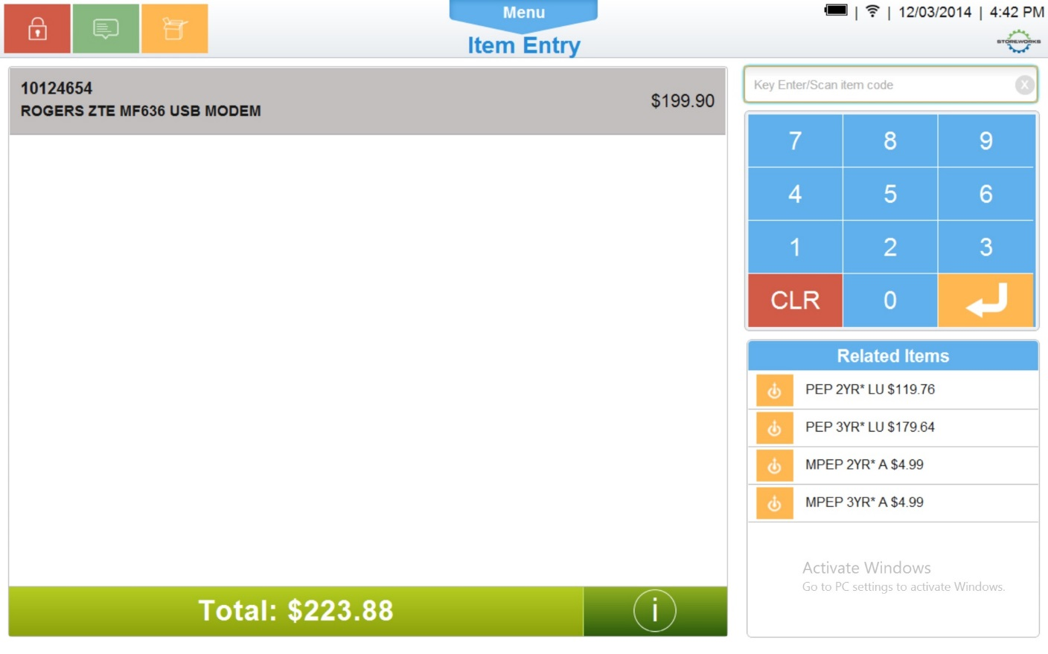

**Figure 3: Item Entry**

### Instruction Text

|  |
| --- |
| **Instructions** |
| None |

### Navigation/Menu Keys

|  |  |  |  |
| --- | --- | --- | --- |
| **Label** | **State** | **Next Screen** | **Notes** |
| Information | Enabled | Information | None |
| Item Entry | See Note | Item Entry | Scanner and keyboard are valid entry methods |
| Sliding Drawer Handle | Enabled | Tran Modify use case | None |
| Suggested Sell | See Notes | Sale use case | * Item selected by tap * Swipe up or down to see additional items (if applicable) * If no suggested sell list, the area is left blank |
| Total | See Notes | Tender use case | Enabled once a transaction is in progress |

### Data/Input Fields

|  |  |  |  |  |  |  |
| --- | --- | --- | --- | --- | --- | --- |
| **Label** | **Editable** | **Req’d?** | **Data Type** | **Min**  **Length** | **Max**  **Length** | **Notes** |
| SKU | No | N/A | Numeric | 1 | 8 | Display Only |
| Price | No | N/A | Currency | 4 | 9 | Display Only |
| Description | No | N/A | Text | 1 | 32 | Display Only |
| Deal Indicator | No | N/A | Text | 1 | 1 | Display Only |
| Subtotal: | No | N/A | Currency | 4 | 9 | Display Only |
| Tax Total: | No | N/A | Currency | 4 | 9 | Display Only |
| Total: | No | N/A | Currency | 4 | 9 | Display Only |
| Balance Due | No | N/A | Currency | 4 | 9 | Display Only |

### Reason Codes

|  |  |  |
| --- | --- | --- |
| **Reason Code** | **Valid Values** | **Default Value** |
| None |  |  |

### Information

|  |  |
| --- | --- |
| **Description** | This message is displayed when the operator selects the information icon on the Item Entry screen. Once selected, the system displays a message containing the register number and the transaction number (not the entire four part key). Acknowledging the message returns the operator to the Item Entry screen. The text is center aligned within the message and <Number> is replaced by the actual register and transaction number. |
| **Message** | Operator <user name>  Register <Number>  Transaction <Number, leave blank if not assigned>  Transaction Salesperson <Entered ID, leave blank if not captured> |
| **Key prompt** | OK |
| **Notes** | None |

### Item Not Authorized to be Sold on Mobile

|  |  |
| --- | --- |
| **Description** | This message is displayed when an item is not allowed to be sold on a mobile device. Acknowledging the message returns the operator to the Item Entry screen. |
| **Message** | The item cannot be sold on mobile device. |
| **Key prompt** | OK |
| **Notes** | Configurable message |

### Open Box Tag Number Not Found

|  |  |
| --- | --- |
| **Description** | This message is displayed when an open box tag number is entered that does not exist in the database. Acknowledging the message returns the operator to the Item Entry screen. |
| **Message** | Open Box tag number is not found. |
| **Key prompt** | OK |
| **Notes** | Configurable message |

### Confirm Line Item Delete with Kit

|  |  |
| --- | --- |
| **Description** | This message is displayed when the operator selects to void an item that is part of a Kit and prompts the operator to verify if the item and kit will be voided.   * If the operator selects No, the item is not voided and the system returns to Sale Screen. * If the operator selects Yes, the system voids the item. |
| **Message** | The item to be voided is part of a Kit. Are you sure you want to void this item and the Kit? |
| **Key prompt** | * Yes * No |
| **Notes** | Configurable message |

### Item Not Authorized to be Sold outside of Related Item Process

|  |  |
| --- | --- |
| **Description** | This message is displayed when an item is sold through item entry but the item is only allowed to be sold within the related item process. Acknowledging the message returns the operator to the Item Entry screen. |
| **Message** | The item can only be sold when linked to another item. |
| **Key prompt** | OK |
| **Notes** | Configurable message |

### Related Item Void Error

|  |  |
| --- | --- |
| **Description** | This message is displayed when the operator selects to void a child related item that cannot be voided until the parent item is line item voided. Acknowledging the message returns the operator to the Item Entry screen. |
| **Message** | Cannot void this item, primary must be voided first. |
| **Key prompt** | OK |
| **Notes** | Configurable message |

### Unable to Sell Schedulable Service Item

|  |  |
| --- | --- |
| **Description** | This message is displayed when the operator attempts to add a schedulable service through item entry and there already are items that were imported from the service order scheduling system. Acknowledging the message returns the operator to the Item Entry screen. |
| **Message** | Cannot void this item, primary must be voided first. |
| **Key prompt** | OK |
| **Notes** | Configurable message |

## Enter Price

This pop over is displayed when an item that is flagged as requiring a price is added to the transaction. The screen prompts the operator to enter the price for the item.

### Mockup

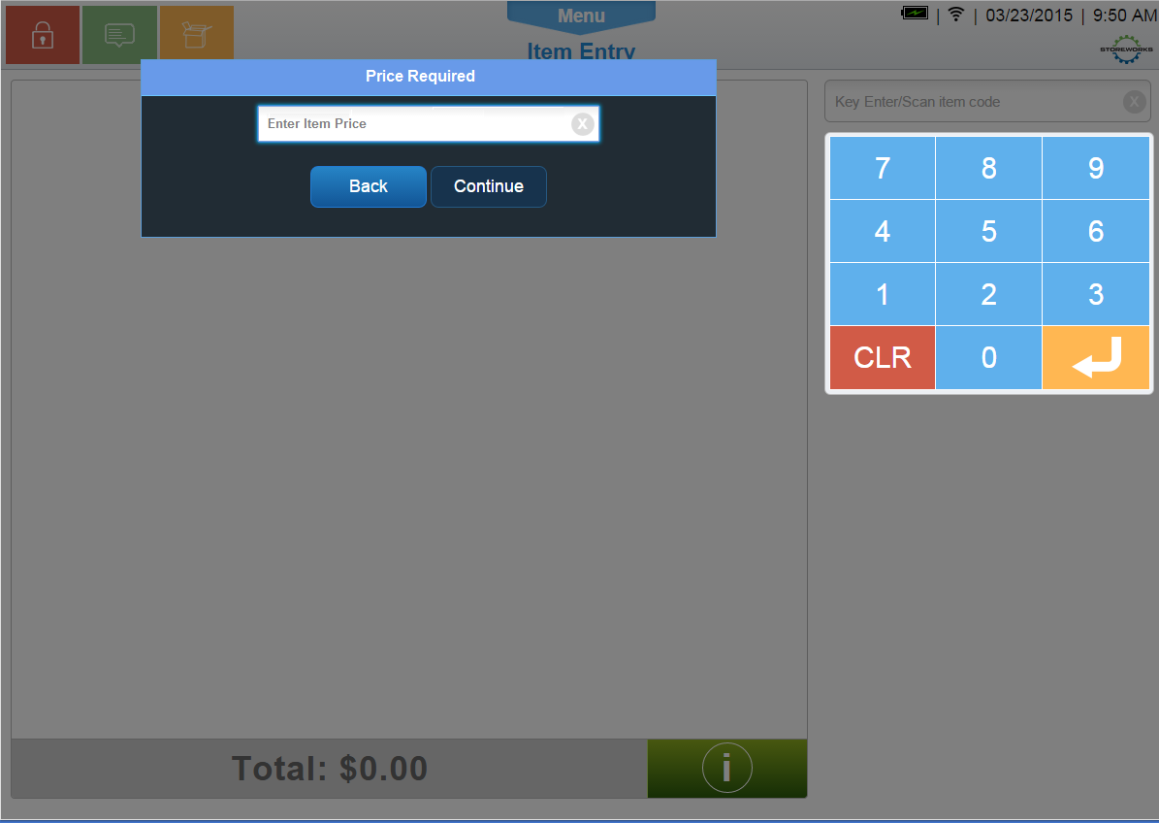

Figure 4: Enter Price

### Instruction Text

|  |
| --- |
| **Instructions** |
| None |

### Navigation/Menu Keys

|  |  |  |  |
| --- | --- | --- | --- |
| **Label** | **State** | **Next Screen** | **Notes** |
| Back | Enabled | Sale use case | None |
| Continue | See Notes | Sale use case | Only enabled when data is entered in the field |

### Data/Input Fields

|  |  |  |  |  |  |  |
| --- | --- | --- | --- | --- | --- | --- |
| **Label** | **Editable** | **Req’d?** | **Data Type** | **Min**  **Length** | **Max**  **Length** | **Notes** |
| Enter item price and select Continue | Yes | Yes | Currency | 4 | 12 | None |

### Reason Codes

|  |  |  |
| --- | --- | --- |
| **Reason Code** | **Valid Values** | **Default Value** |
| None |  |  |

## Enter Open Box Price

This pop over appears if there is no open box price associated with the tag number and the system prompts to capture the open box price of the item. This is the same pop over used for items that require price entry.

### Mockup

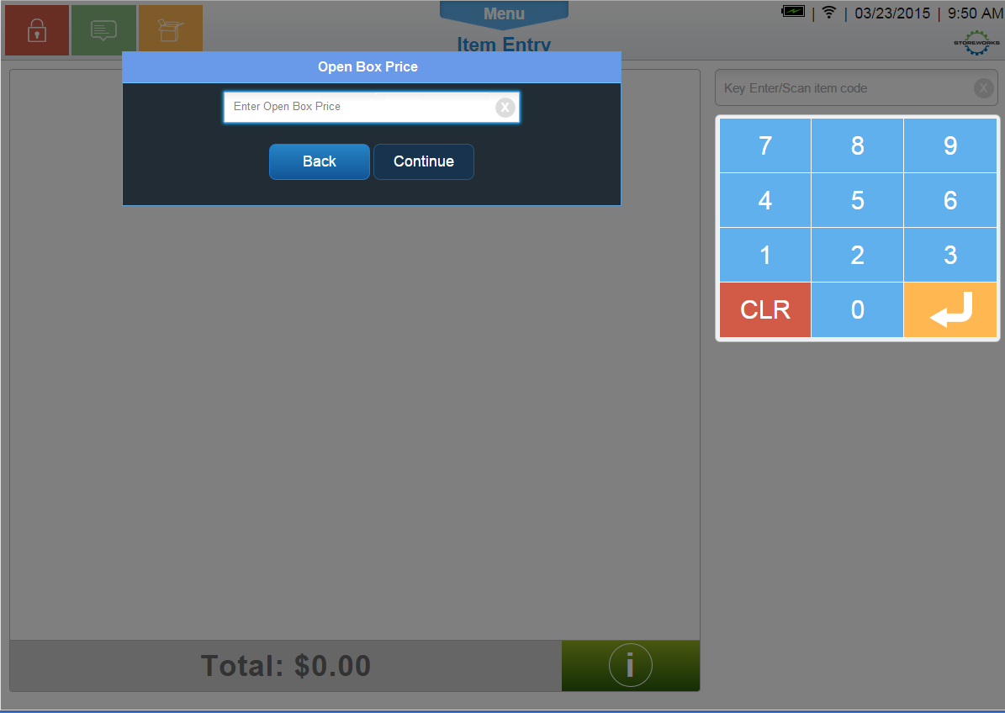

Figure 5: Enter Open Box Price

### Instruction Text Enhancements

|  |
| --- |
| **Instructions** |
| None |

### Navigation/Menu Key Enhancements

|  |  |  |  |
| --- | --- | --- | --- |
| **Label** | **State** | **Next Screen** | **Notes** |
| Back | Enabled | Sale use case | None |
| Continue | See Notes | Sale use case | Only enabled when data is entered in the field |

### Data/Input Field Enhancements

|  |  |  |  |  |  |  |
| --- | --- | --- | --- | --- | --- | --- |
| **Label** | **Editable** | **Req’d?** | **Data Type** | **Min**  **Length** | **Max**  **Length** | **Notes** |
| Enter item price and select Continue | Yes | Yes | Currency | 4 | 12 | None |

### Reason Code Enhancements

|  |  |  |
| --- | --- | --- |
| **Reason Code** | **Valid Values** | **Default Value** |
| None |  |  |

# *Business Sign Off*

|  |  |  |
| --- | --- | --- |
| **Name** | **Organization** | **Date** |
|  |  |  |

# *Revision History*

|  |  |  |  |
| --- | --- | --- | --- |
| **Reviser** | **Revision** | **Date** | **Version** |
| Amy Lackas | Initial document created. This version includes the following changes: Layaway Deposit, Pre-Order Deposit, Raincheck. | 10/28/2013 | 1.0 |
| Amy Byers | * Added Quantity Required Items * Updated screen mockups | 3/23/2015 | 1.1 |

# *Appendix A: Glossary*

|  |  |
| --- | --- |
| **Term** | **Definition** |
| UPC | Universal Product Code |
| Open Box Item | Items that are returned open and functional. The product can then be re-sold as an open box item. |
| Open Box Tag | The 9-character value associated with the open box item. The entry of this value in Item Entry triggers the Open Box Item use case. An open box tag is associated with one item, but an item can be associated with multiple open box tags. Also called License Plate # (LP#) |
| Register Number | A register Number is not the unique device ID, but is the 1-2 digit ID assigned to the device to be used in the creation of the Transaction Key and logged in the POSLog, EJ, and on the Receipt. There can be multiple devices associated with one register Number. |
| Device ID | A unique identification associated with the device. This ID is not logged in the POSLog, EJ or Receipt. |